UNIVERSITY INSTITUTE OF ENGINEERING AND TECHNOLOGY, PANJAB UNIVERSITY, CHANDIGARH

**COMPUTER NETWORKS AND SECURITY**



**Lab File**

Roll No: UE163095

Computer Science and Engineering | 6th SEM

Submitted By: Shivank Bali

**INDEX**

|  |  |  |
| --- | --- | --- |
| **S.No.** | **Date** | **Practical** |
| **1** |  | Introduction to hubs switches routers and bridges |
| **2** |  | Introduction to cables and connectors |
| **3** |  | How to use crimping tool on twisted pair cable and RJ45 connector |
| **4** |  | Introduction to various commands used for troubleshooting networks |
| **5** |  | Network Topologies |
| **6** |  | Network Sharing |
| **7** |  | Hamming Distance |
| **8** |  |  |
|  |  |  |

**Practical 1**

**Aim :-** Familiarisation with networking components and devices

* Hubs / Repeaters
* Switches
* Bridges
* Routers

**Hubs :-**

A hub is a small, rectangular, inexpensive device that joins together multiple network-enabled devices. They're often made of plastic and receive power from an ordinary wall outlet.

The purpose of a hub is to join multiple computers or other network devices together to form a single network segment. On this network segment, all devices can communicate directly with each other.

Ethernet hubs vary in their speed (network data rate, or bandwidth). Original Ethernet hubs were rated at just 10 Mbps, but modern ones have 100 Mbps support and usually offer both 10 Mbps and 100 Mbps capabilities (known as *dual-speed* or *10/100* hubs).

The number of ports an Ethernet hub supports also varies. Four- and five-port Ethernet hubs are most common in home networks, but eight- and 16-port hubs can be found in some home and small office environments.

Hubs can be connected to each other this is called daisy chaining. It is used to expand the total number of devices a hub network can support.

For daisy chaining connect one end of a cable to a port on one Hub and the other end to a port on the other Hub. On some hubs, a special designated port is used for daisy chaining.

Types of hubs :

* *Passive hubs* don't amplify the electrical signal of incoming packets before broadcasting them out to the network.
* *Active hubs* perform amplification, much like a repeater.

|  |  |
| --- | --- |
|  | HUBS  HUB |

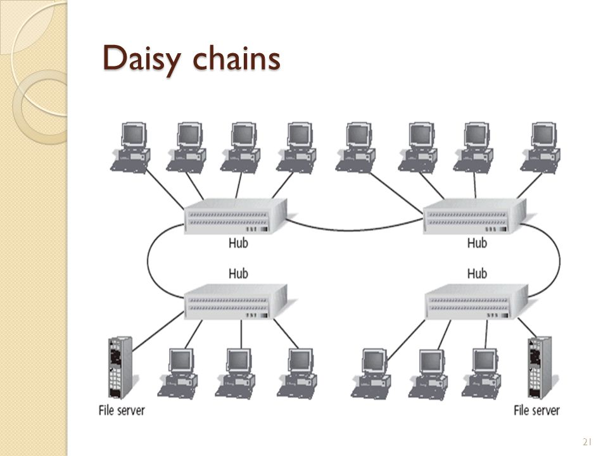

**Switches :-**  
A network switch (also called switching hub, bridging hub, officially MAC bridge) is a computer networking device that connects devices together on a computer network by using packet switching to receive, process, and forward data to the destination device.  
  
A network switch is a multiport network bridge that uses hardware addresses to process and forward data at the data link layer (layer 2) of the OSI model. Some switches can also process data at the network layer (layer 3) by additionally incorporating routing functionality. Such switches are commonly known as layer-3 switches or multilayer switches.  
  
Switches for Ethernet are the most common form of network switch. The first Ethernet switch was introduced by Kalpana in 1990. Switches also exist for other types of networks including Fibre Channel, Asynchronous Transfer Mode, and InfiniBand.  
  
Unlike less advanced repeater hubs, which broadcast the same data out of each of its ports and let the devices decide what data they need, a network switch forwards data only to the devices that need to receive it.

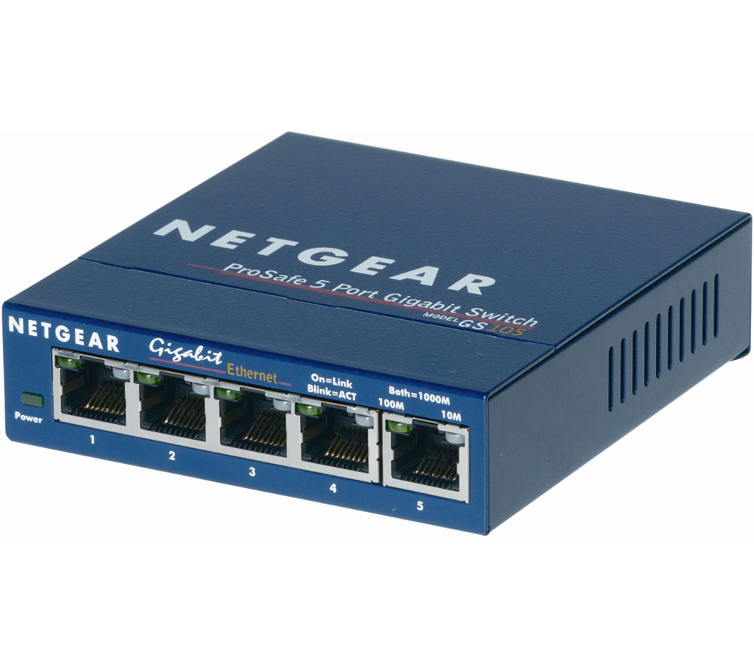

**Bridges :-**  
A bridge is a type of computer network device that provides interconnection with other bridge networks that use the same protocol.

Bridge devices work at the data link layer of the Open System Interconnect (OSI) model, connecting two different networks together and providing communication between them. Bridges are similar to repeaters and hubs in that they broadcast data to every node. However, bridges maintain the media access control (MAC) address table as soon as they discover new segments, so subsequent transmissions are sent to only to the desired recipient.

Bridges are also known as Layer 2 switches.

A network bridge device is primarily used in local area networks because they can potentially flood and clog a large network thanks to their ability to broadcast data to all the nodes if they don’t know the destination node's MAC address.

A bridge uses a database to ascertain where to pass, transmit or discard the data frame.

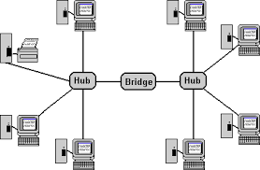

**Routers :-**

A router is a device that analyzes the contents of data packets transmitted within a network or to another network. Routers determine whether the source and destination are on the same network or whether data must be transferred from one network type to another, which requires encapsulating the data packet with routing protocol header information for the new network type.

When several routers are used in a collection of interconnected networks, they exchange and analyze information, and then build a table of the preferred routes and the rules for determining routes and destinations for that data. As a network interface, routers convert computer signals from one standard protocol to another that's more appropriate for the destination network.

Large routers determine interconnectivity within an enterprise, between enterprises and the Internet, and between different internet service providers (ISPs); small routers determine interconnectivity for office or home networks. ISPs and major enterprises exchange routing information using border gateway protocol (BGP).

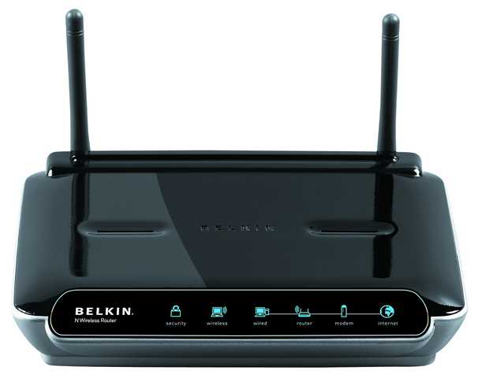

**Practical 2**

**Aim :-** Introduction to cables and connectors

**Network and Communication Cables**

Network and communication cables are network hardware used to connect one network device to other network devices. For example, connecting two or more computers to share printers and scanners; connecting several severs to an access switch. The range covers data and Ethernet cable assemblies, including twisted pair cable, coaxial cable, optical fiber cable, power line, etc. The twisted pair cable, coaxial cable and optical fiber cable are categories that are most often referred to.

Optic Fibre cables and connectors

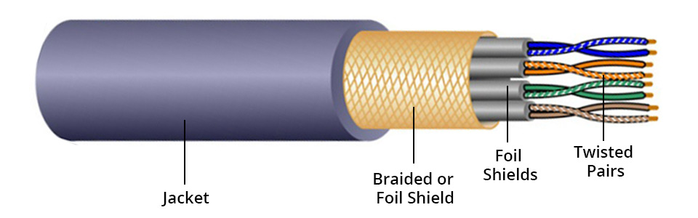

Twisted pair cables are often shielded in an attempt to prevent electromagnetic interference. Twisted pair with shielding are known as shielded twisted pair (STP). In contrast to STP, unshielded twisted pair (UTP) is not surrounded by any shielding.

STP cable is also divided by overall shield and individual shield. Individual shielded twisted pair is with aluminum foil for each twisted pair or quad. This type of shielding protects cable from external electromagnetic interference (EMI) entering or exiting the cable and also protects neighboring pairs from crosstalk. Overall shielded twisted pair is with overall foil or braided shield across all of the pairs within the 100 Ω twisted pair cable. This type of shielding helps prevent EMI from entering or exiting the cable. One STP cable can have both overall and individual shielding.

UTP cable without shielding is more prone to outside interference. For this reason, this cable type is more often found in indoor telephone applications. Outdoor telephone cables contain hundreds or thousands pairs. Pairs that have the same twisted rate within the cable can experience some degree of crosstalk, so wire pairs are usually selected carefully within a large cable to reduce the crosstalk.

Most UTP cable uses RJ45 connectors, which look like telephone connectors (RJ11) but have eight wires instead of four.

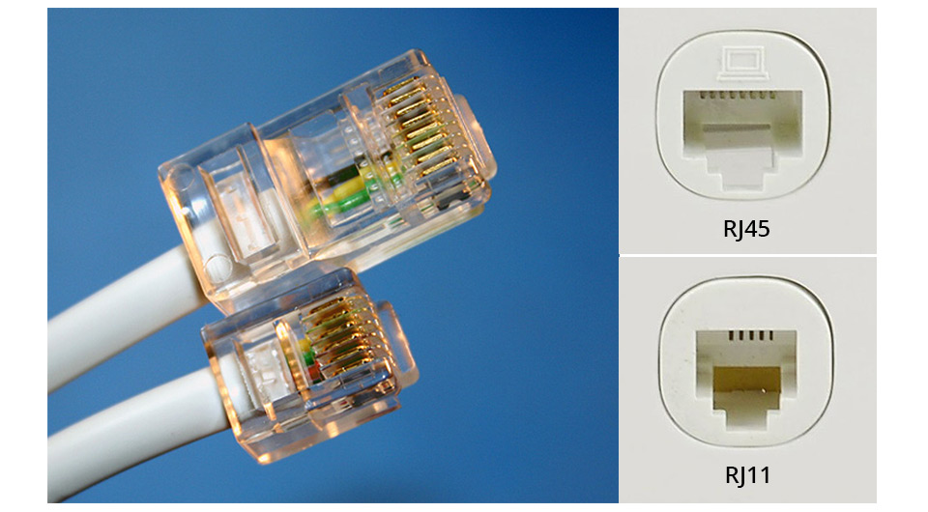

**Coaxial Cable:**

Coaxial cable is a type of cable that has an inner conductor surrounded by a tubular insulating layer, surrounded by a tubular conducting shield. The inner conductor and the outer shield share a geometric axis. Many coaxial cable has an insulating outer sheath or jacket.

Coaxial cable is used as a transmission line for radio frequency (RF) signals. Its applications include feedlines connecting radio transmitters and receivers with their antennas, computer network connections, digital audio, and distributing cable television signals. Coaxial cable has an obvious advantage over other types of radio transmission line. In a good coaxial cable, the electromagnetic field carrying the signal exists only in the space between the inner conductor and the outer conducting shield. For this reason, coaxial cables are allowed to be installed next to metal objects without power losses that occur in other types of radio transmission line.

Many coaxial connector types are available in the audio, digital, video, RF and microwave industries, each designed for a specific purpose and application. One consideration the number of connect-disconnect cycles that a connector pair could withstand while still performing as expected. Here are some common coaxial connector types.

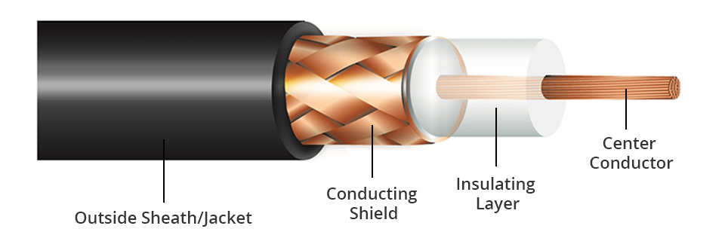

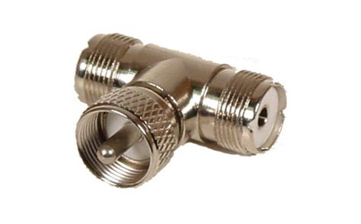

**Optical Fibre Cables**

Optical fiber cabling is an excellent transmission medium for its high data capacity and supported long distances. It is indispensable in any fiber optic network. It has a fibre/glass core within a rubber outer coating and uses beams of light rather than electrical signals to relay data. Because light doesn't diminish over distance the way electrical signals do, this cabling can run for distances measured in kilometers with transmission speeds from 10 Mbps up to 100 Gbps or higher.

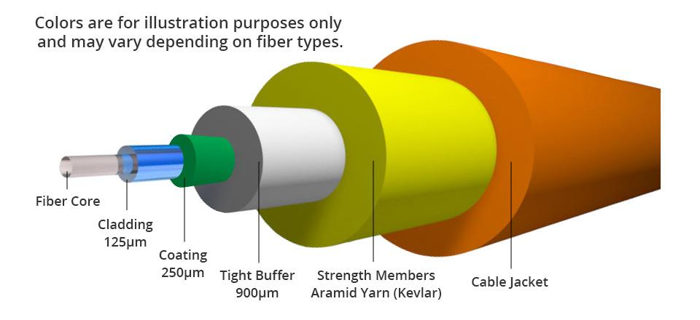

The inner fiber can be either single mode or multimode. Generally, a single mode fiber core is 9/125µm wide, whereas a multimode fiber core can be 62.5/125µm or 50/125µm wide. Only the early OM1 is 62.5/125µm fiber, the later generations OM2, OM3, OM4, OM5 50/125µm fiber. The letters “OM” stand for optical multimode. Both multimode fiber (MMF) and single mode fiber (SMF) can be used for high-speed transmission. MMF is often for short reach while SMF is for long reach.

Fibre optic cables connectors

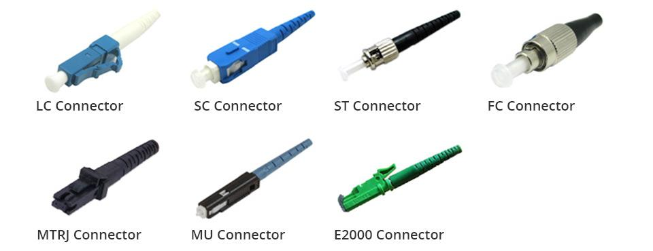

**Practical 3**

**Aim :-** How to use crimping tool on twisted pair cable and RJ45 connector

**What Is Straight-Through Cable?**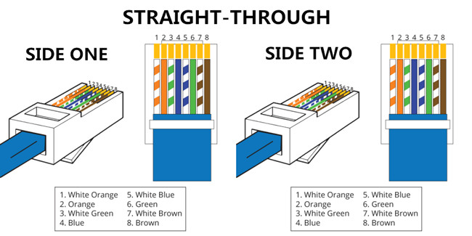

A straight-through cable is a type of twisted pair cable that is used in local area networks to connect a computer to a network hub such as a router. This type of cable is also sometimes called a patch cable and is an alternative to wireless connections where one or more computers access a router through a wireless signal. On a straight-through cable, the wired pins match. Straight-through cable use one wiring standard: both ends use T568A wiring standard or both ends use T568B wiring standard. The following figure shows a straight-through cable of which both ends are wired as the T568B standard.

**What Is Crossover Cable?**

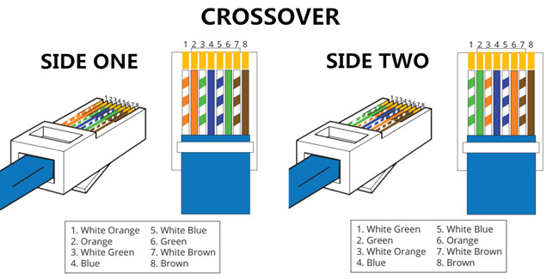

An Ethernet crossover cable is a type of Ethernet cable used to connect computing devices together directly. Unlike straight-through cable, crossover cables use two different wiring standards: one end uses the T568A wiring standard, and the other end uses the T568B wiring standard. The internal wiring of Ethernet crossover cables reverses the transmit and receive signals. It is most often used to connect two devices of the same type: e.g. two computers (via network interface controller) or two switches to each other.

Straight Cable

* Both side T568A or T568B

Cross Cable

* One side T568A and another side T568B

**Difference between straight-through and crossover cables**

Straight-through and crossover cables are wired differently from each other. One easy way to tell what you have is to look at the order of the colored wires inside the RJ45 connector. If the order of the wires is the same on both ends, then you have a straight-through cable. If not, then it’s most likely a crossover cable or was wired wrong. At present, the straight-through cable is much more popular than crossover cable and is widely used by people.

**Different Cabling Schemes :-**

|  |  |
| --- | --- |
| T568A   * White Green * Green * White Orange * Blue * White Blue * Orange * White Brown * Brown   T568B   * White Orange * Orange * White Green * Blue * White Blue * Green * White Brown * Brown |  |

Steps for crimping twisted pair cables

* Get cable and your RJ-45 connectors.
* Strip 1 to 2 inches (2.5 to 5.1 cm) of the outer skin at the end of the cable wire by making a shallow cut in the skin with a utility knife.
* Fold each pair of wires backwards to expose the core of the cable.
* Cut off the core and discard.
* Straighten the twisted wires using 2 pair of tweezers.
* Arrange the untwisted wires in a row, placing them into the position, running from right to left, in which they will go into the RJ-45 connector:
* Trim the untwisted wires to a suitable length by holding the RJ-45 connector next to the wires.
* Insert the wires into the RJ-45 connector, making sure that they stay aligned and each color goes into its appropriate channel.
* Use the crimping tool to crimp the RJ-45 connector to the cable by pressing the jacket and cable into the connector so that the wedge at the bottom of the connector is pressed into the jacket.
* Follow the instructions above to crimp an RJ-45 connector to the opposite end of the cable.
* Use a cable tester to assure that your cable is working properly when both ends are crimped.

Crimping Tool



**Practical 4**

Commands

* Ping
* Ipconfig
* traceroute
* netstat

PING :

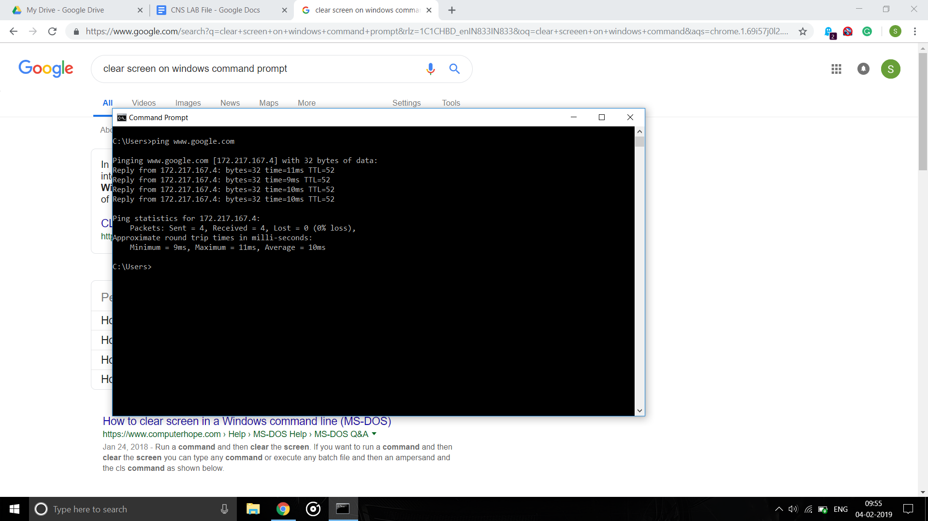

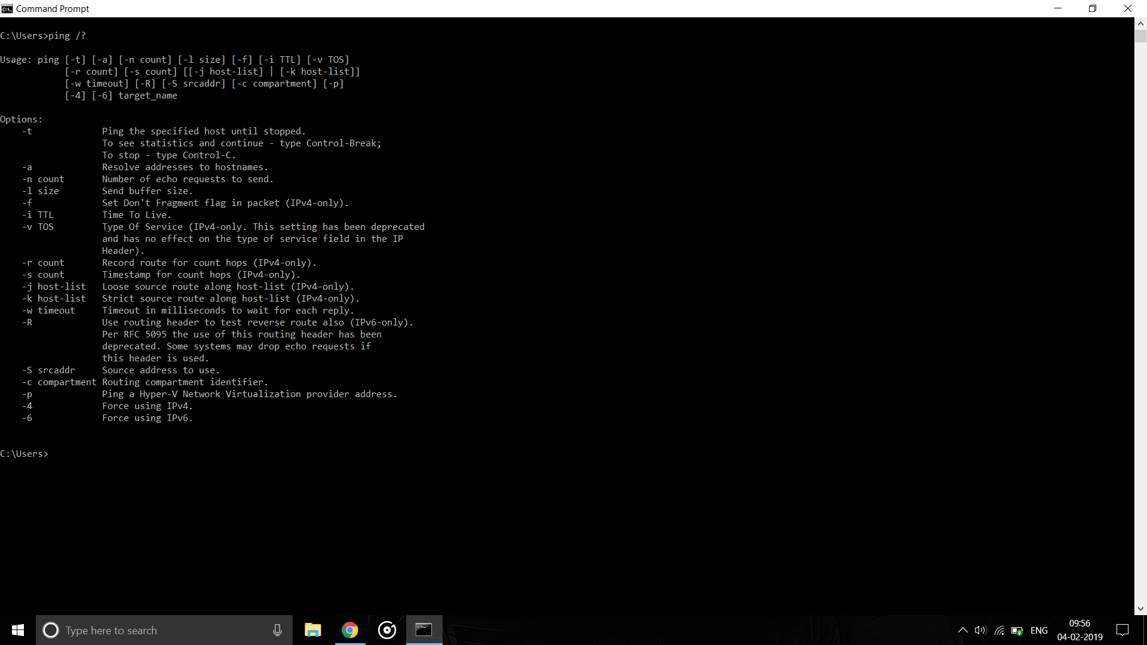

-t

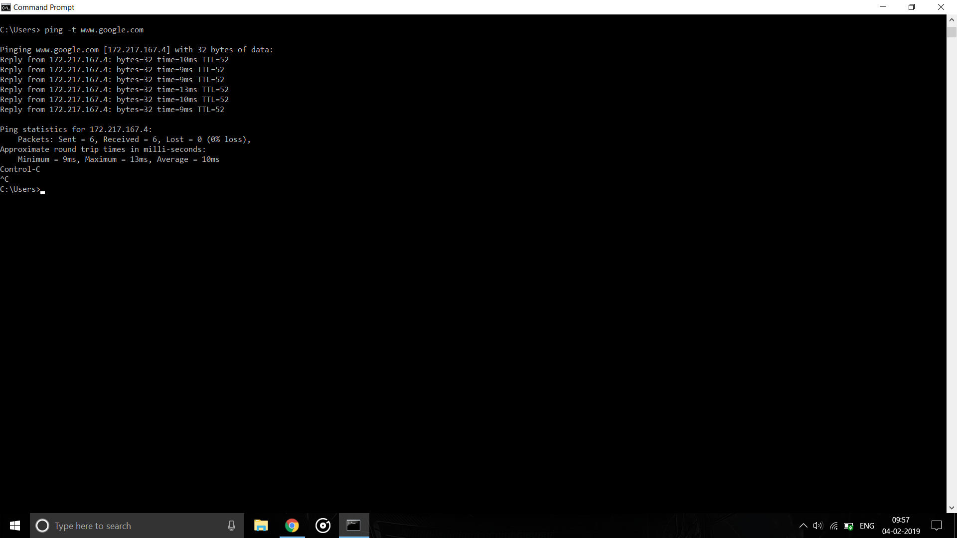

-f

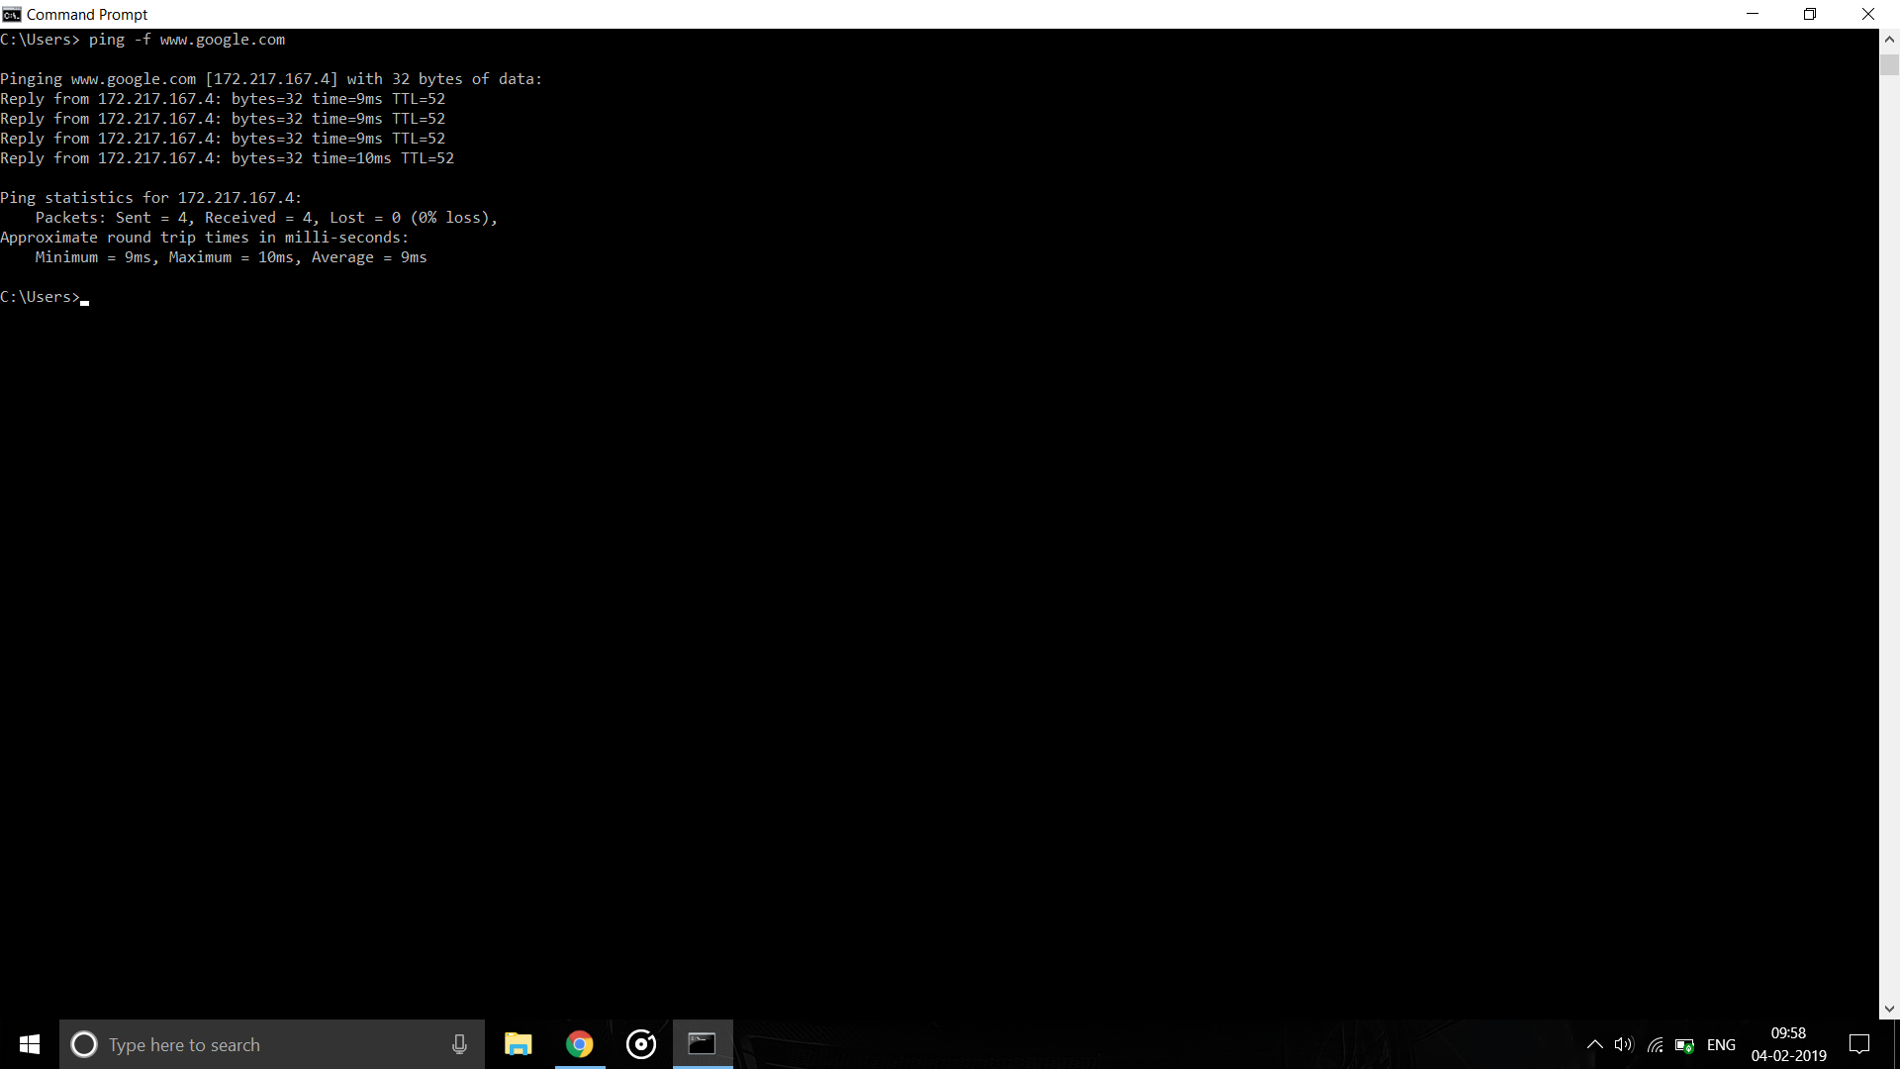

-l

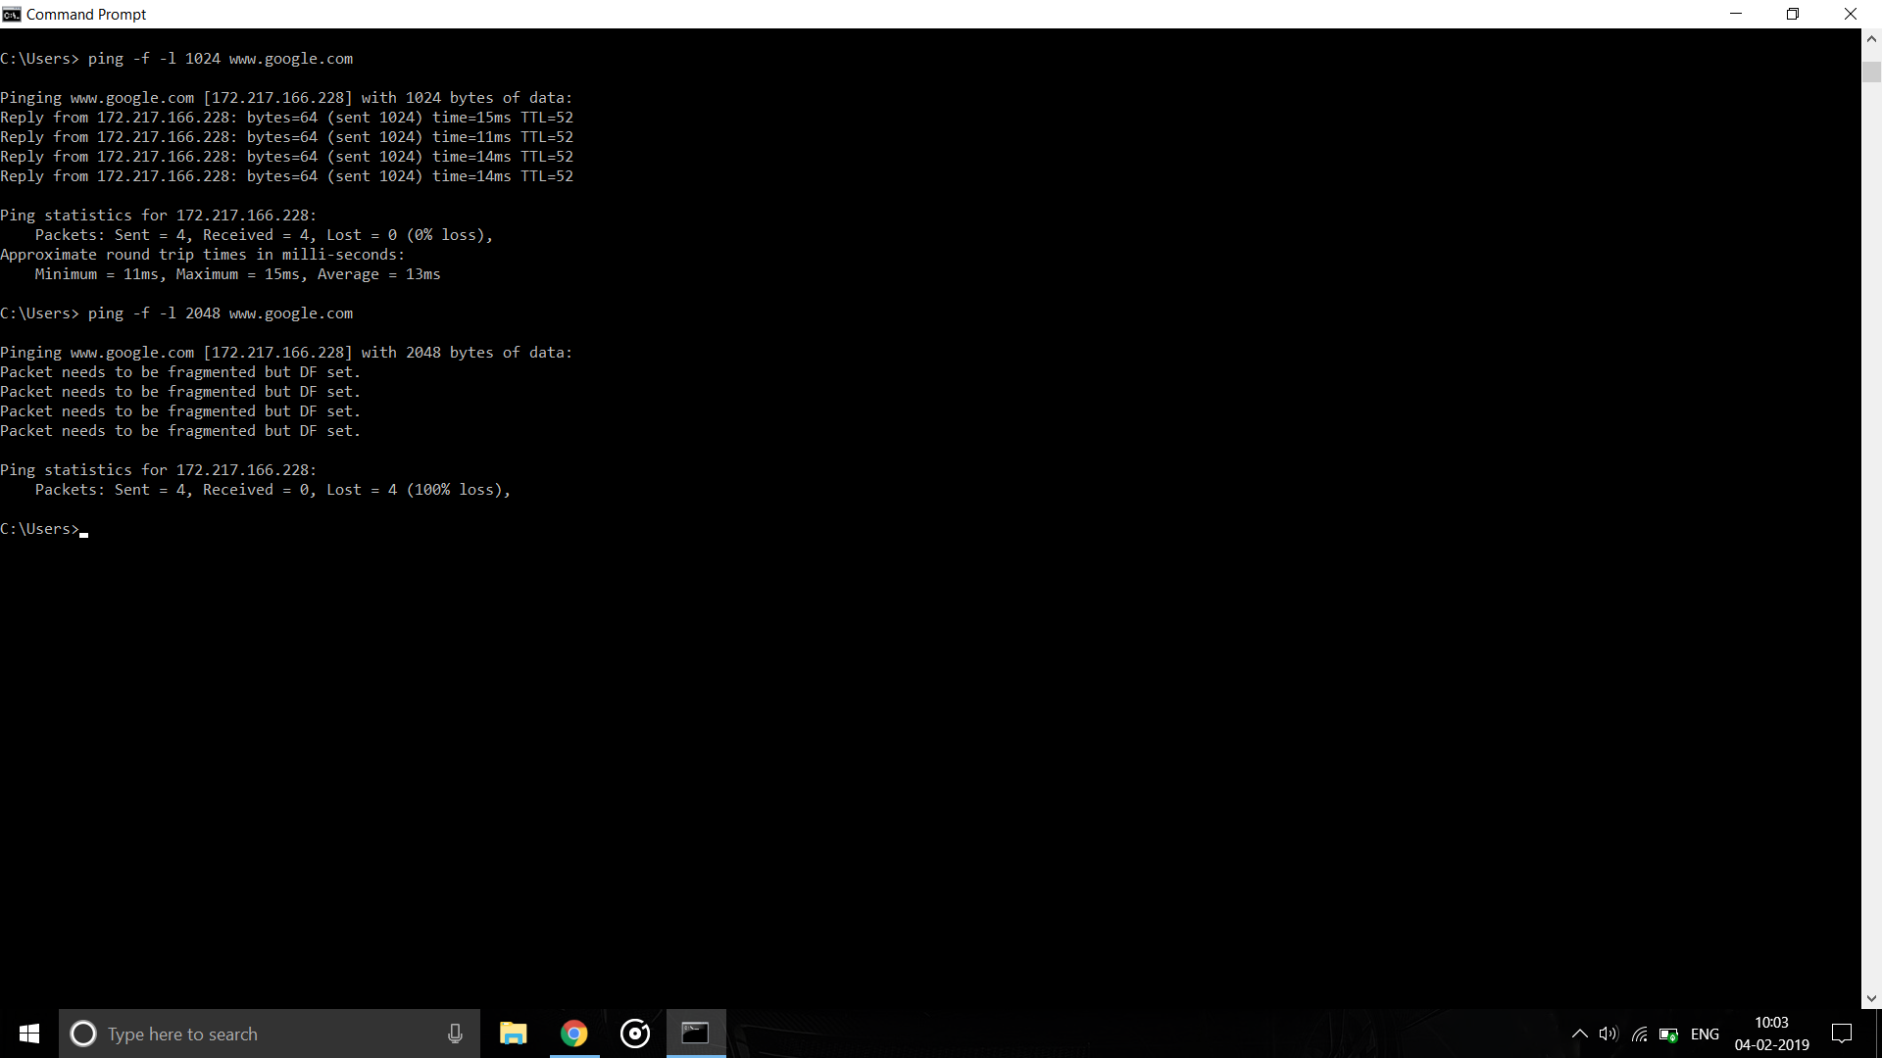

-n

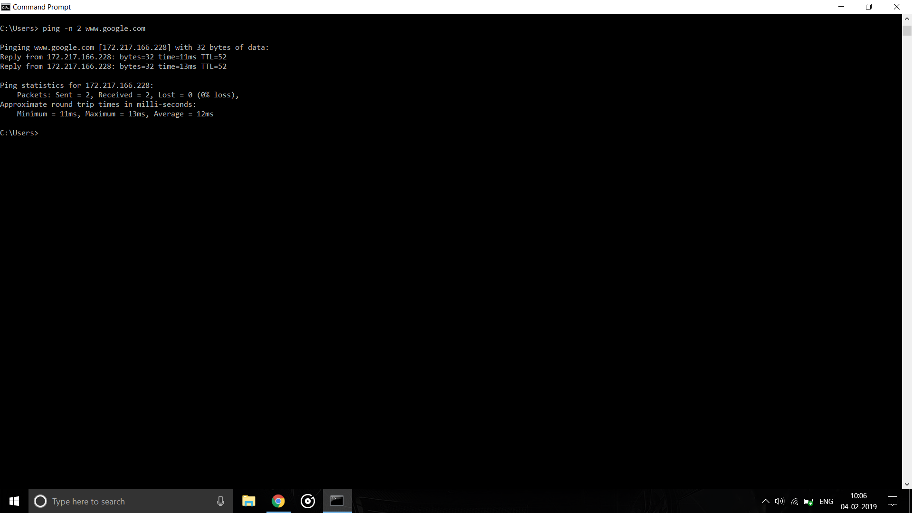

-i

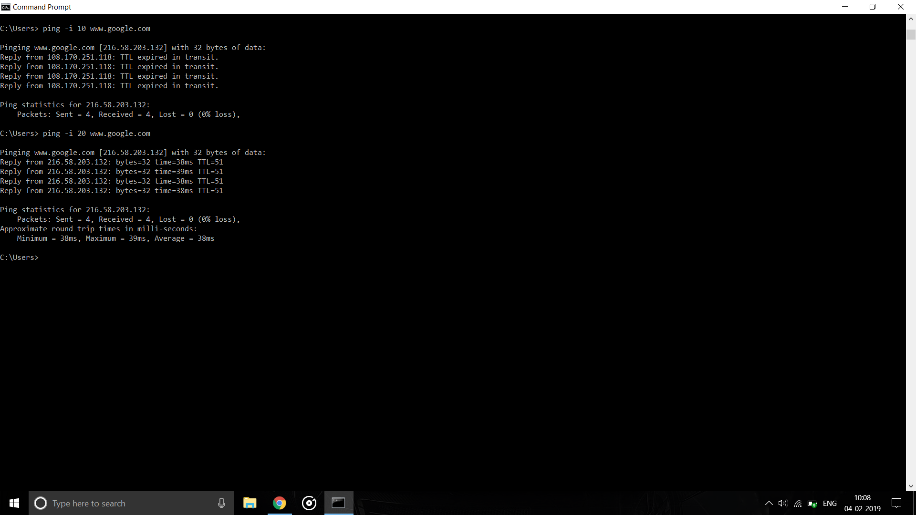

ipconfig

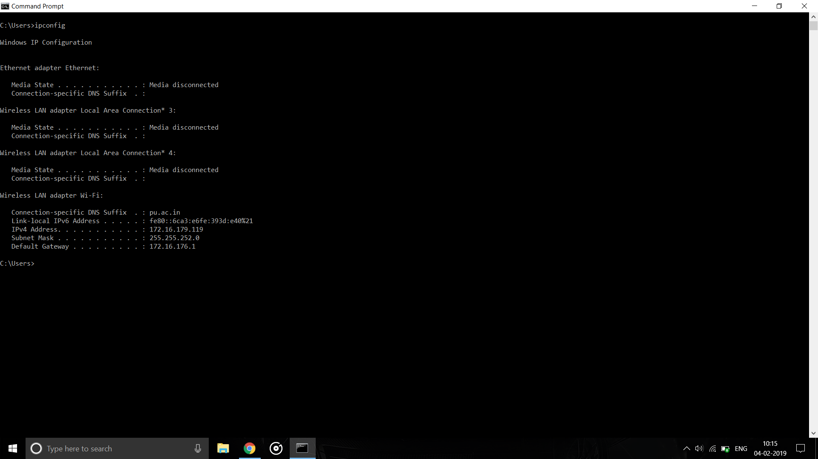

ipconfig /all

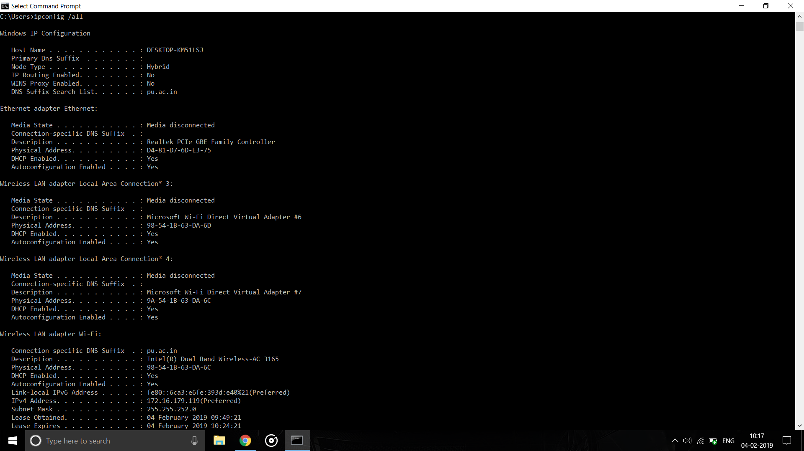

Ipconfig /renew

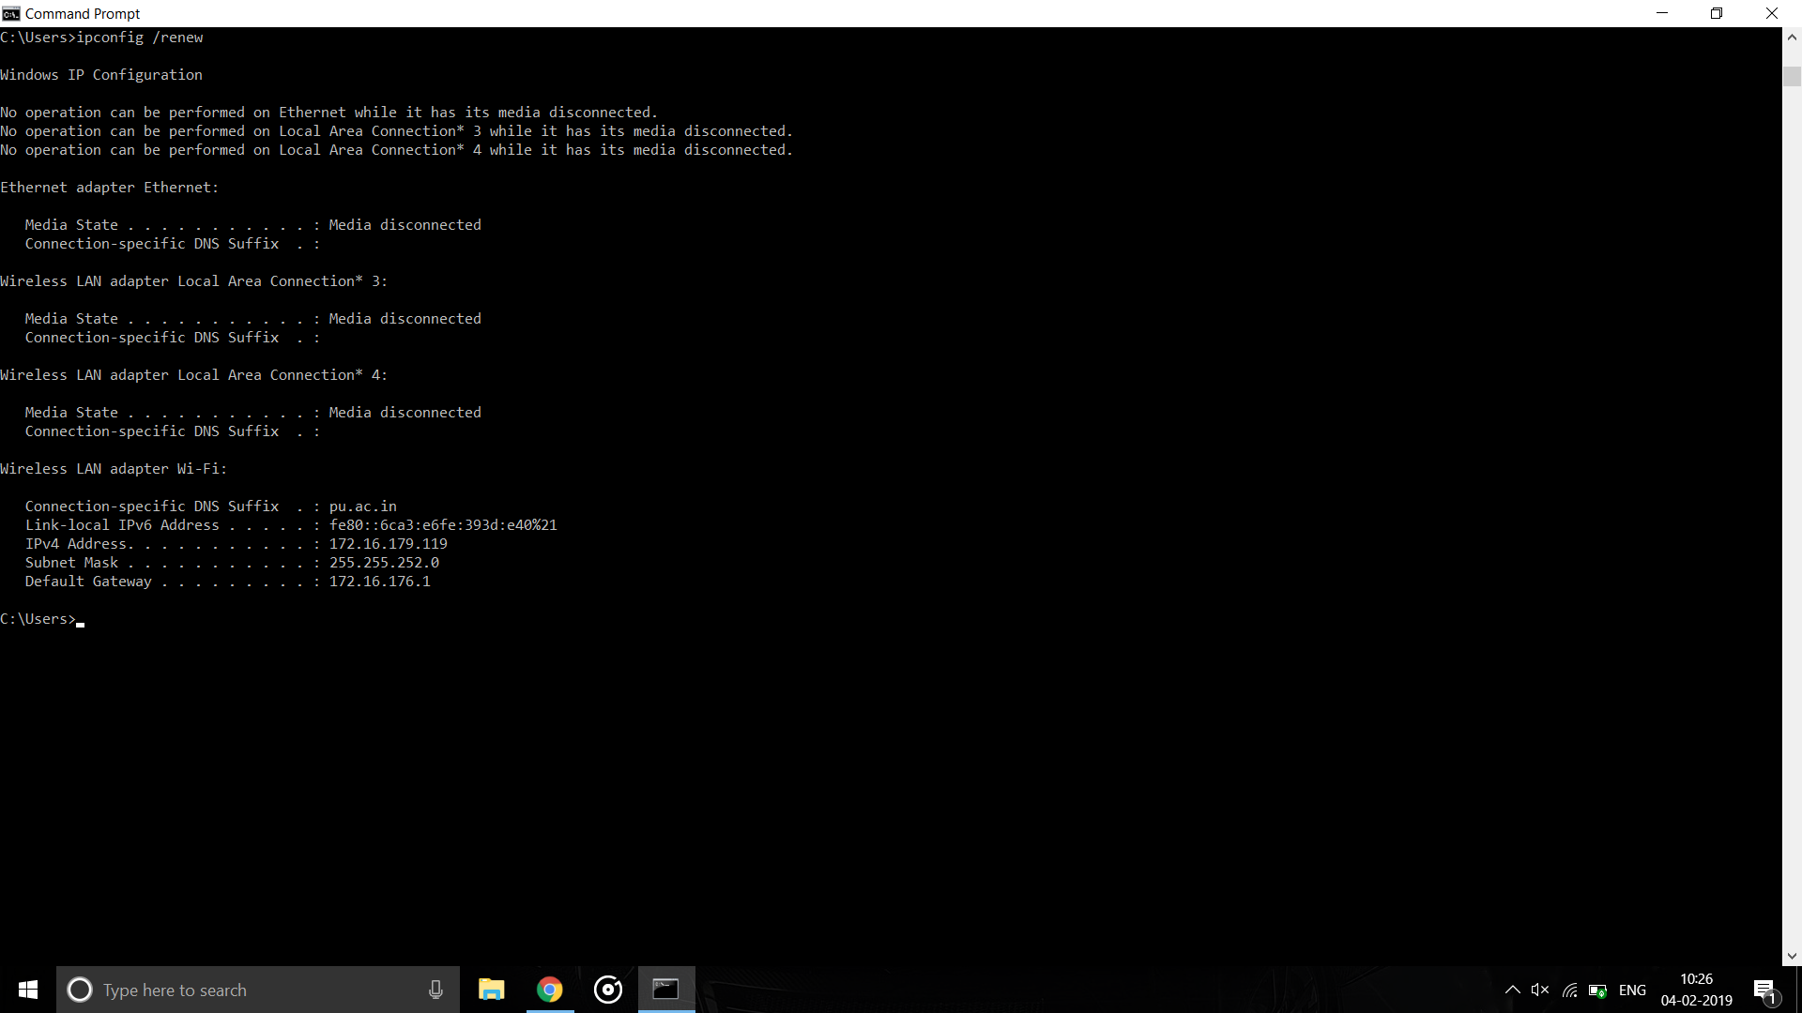

ipconfig /release

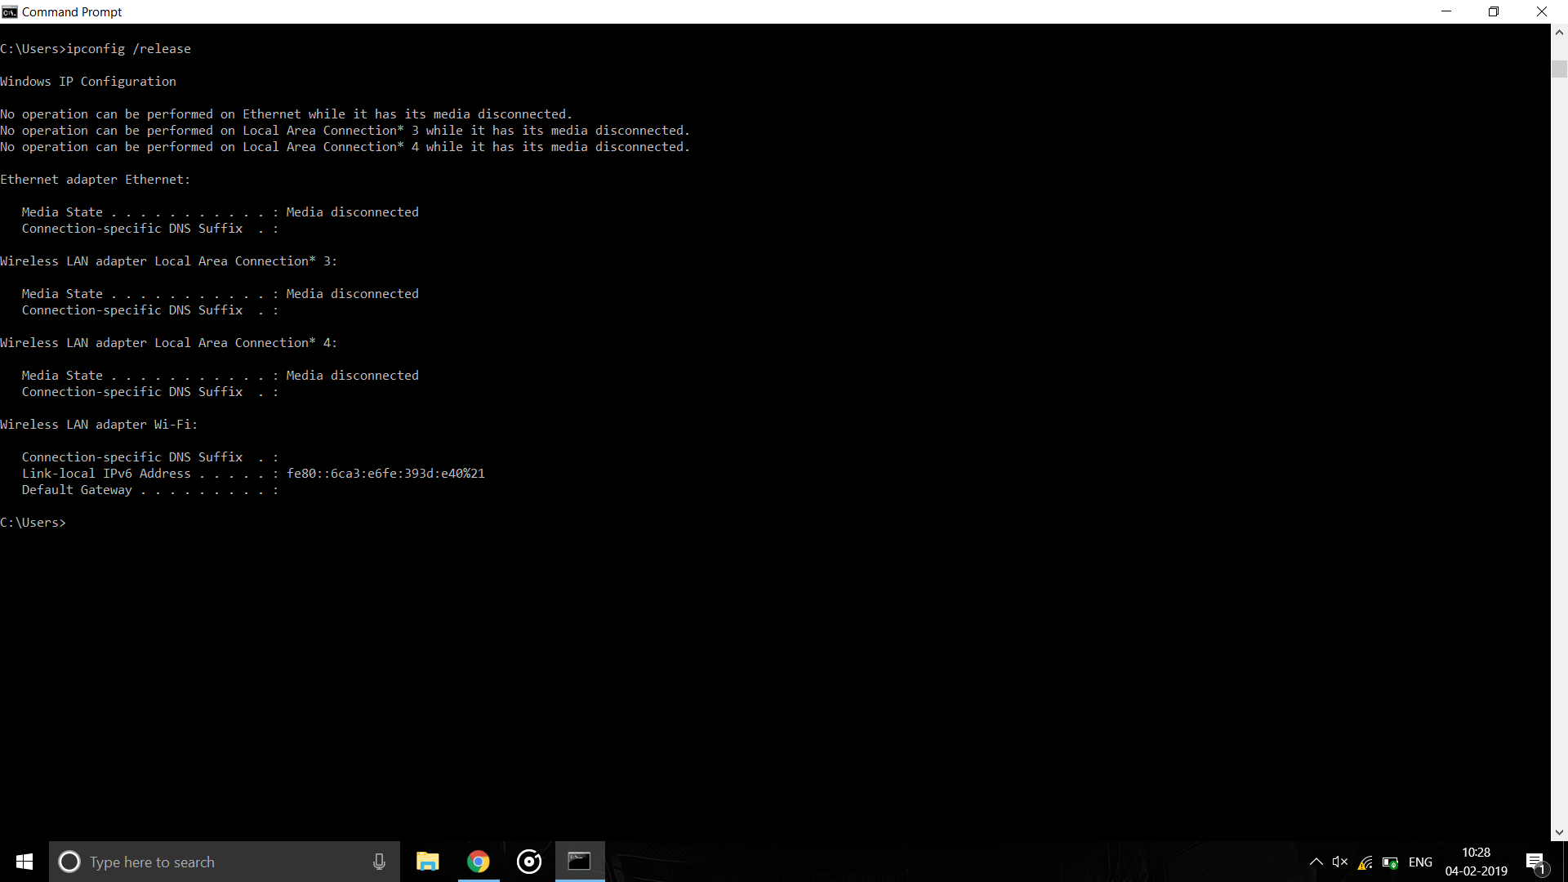

ipconfig /flushdns

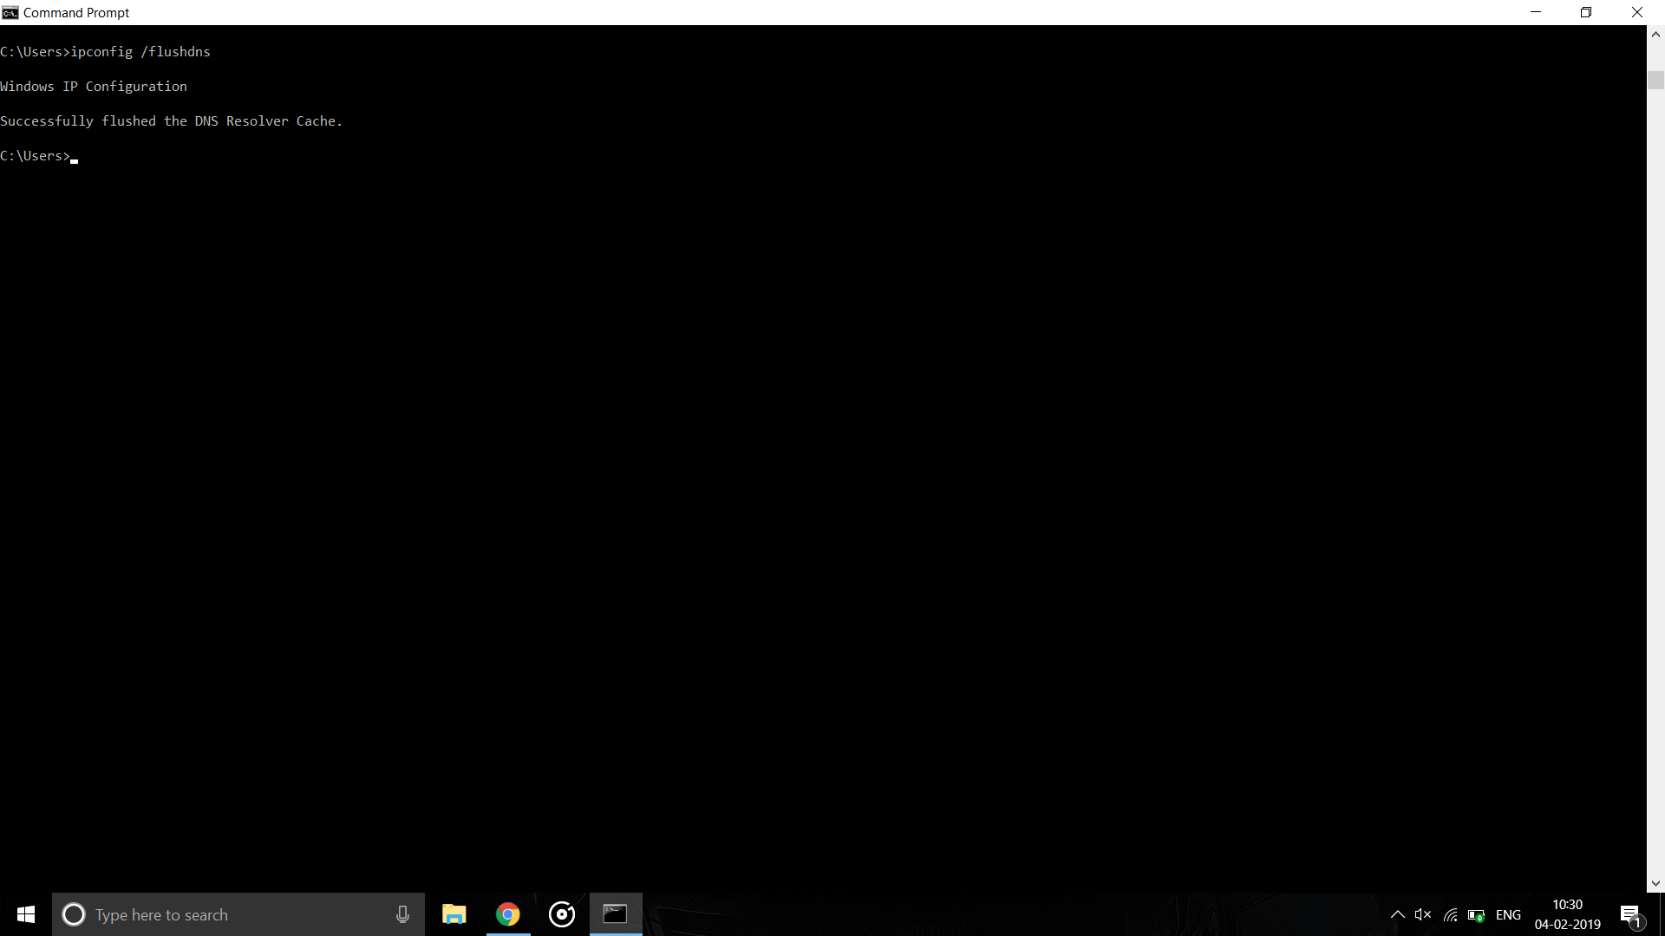

tracert command

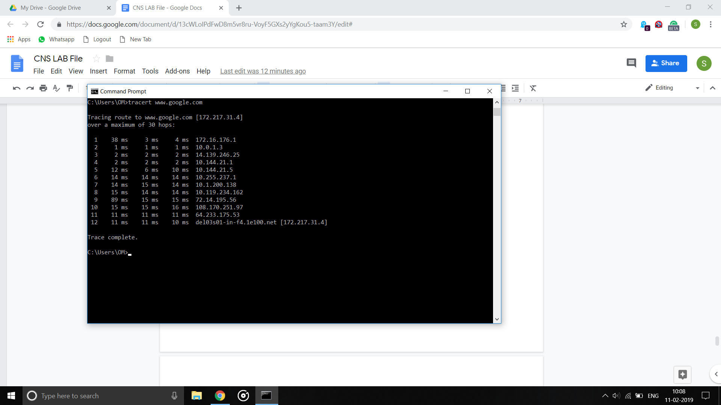

-h

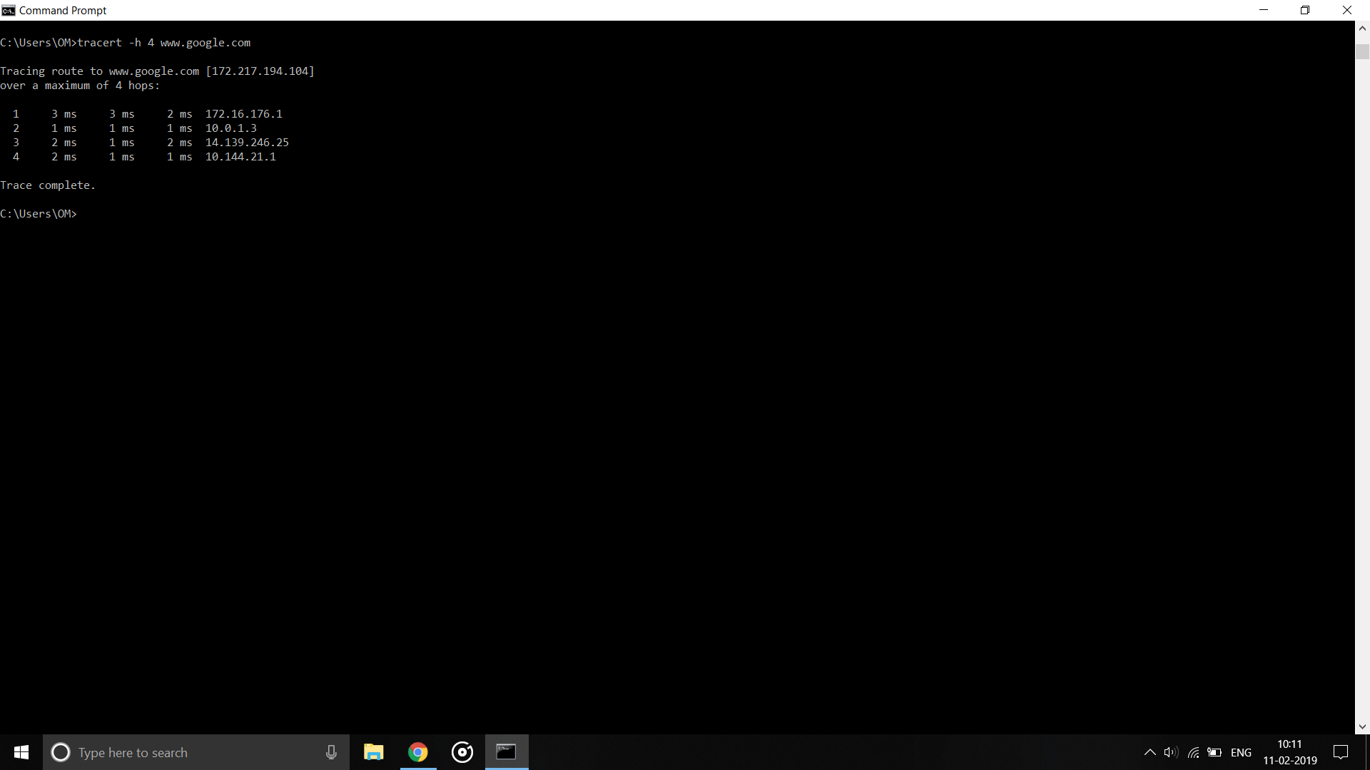

-d

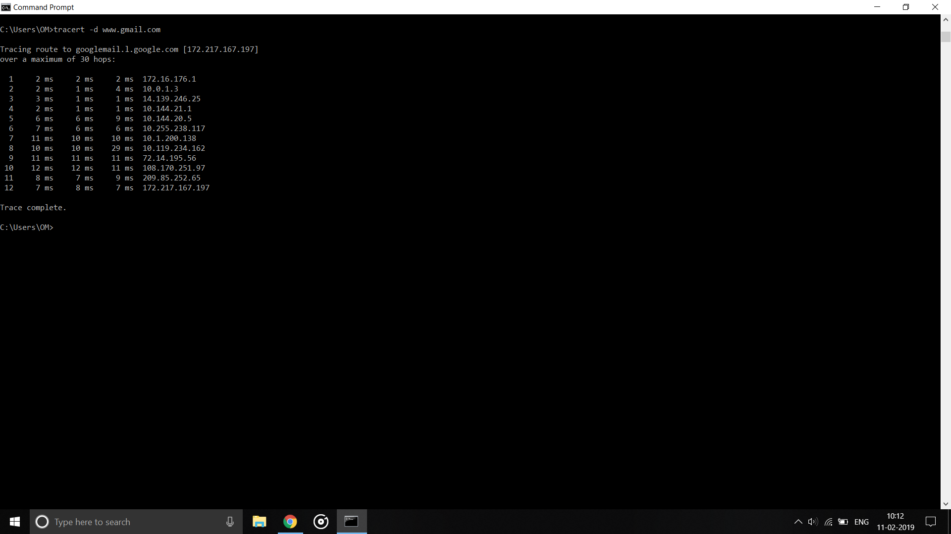

**Netstat**

It is used to display all network listening ports

-a

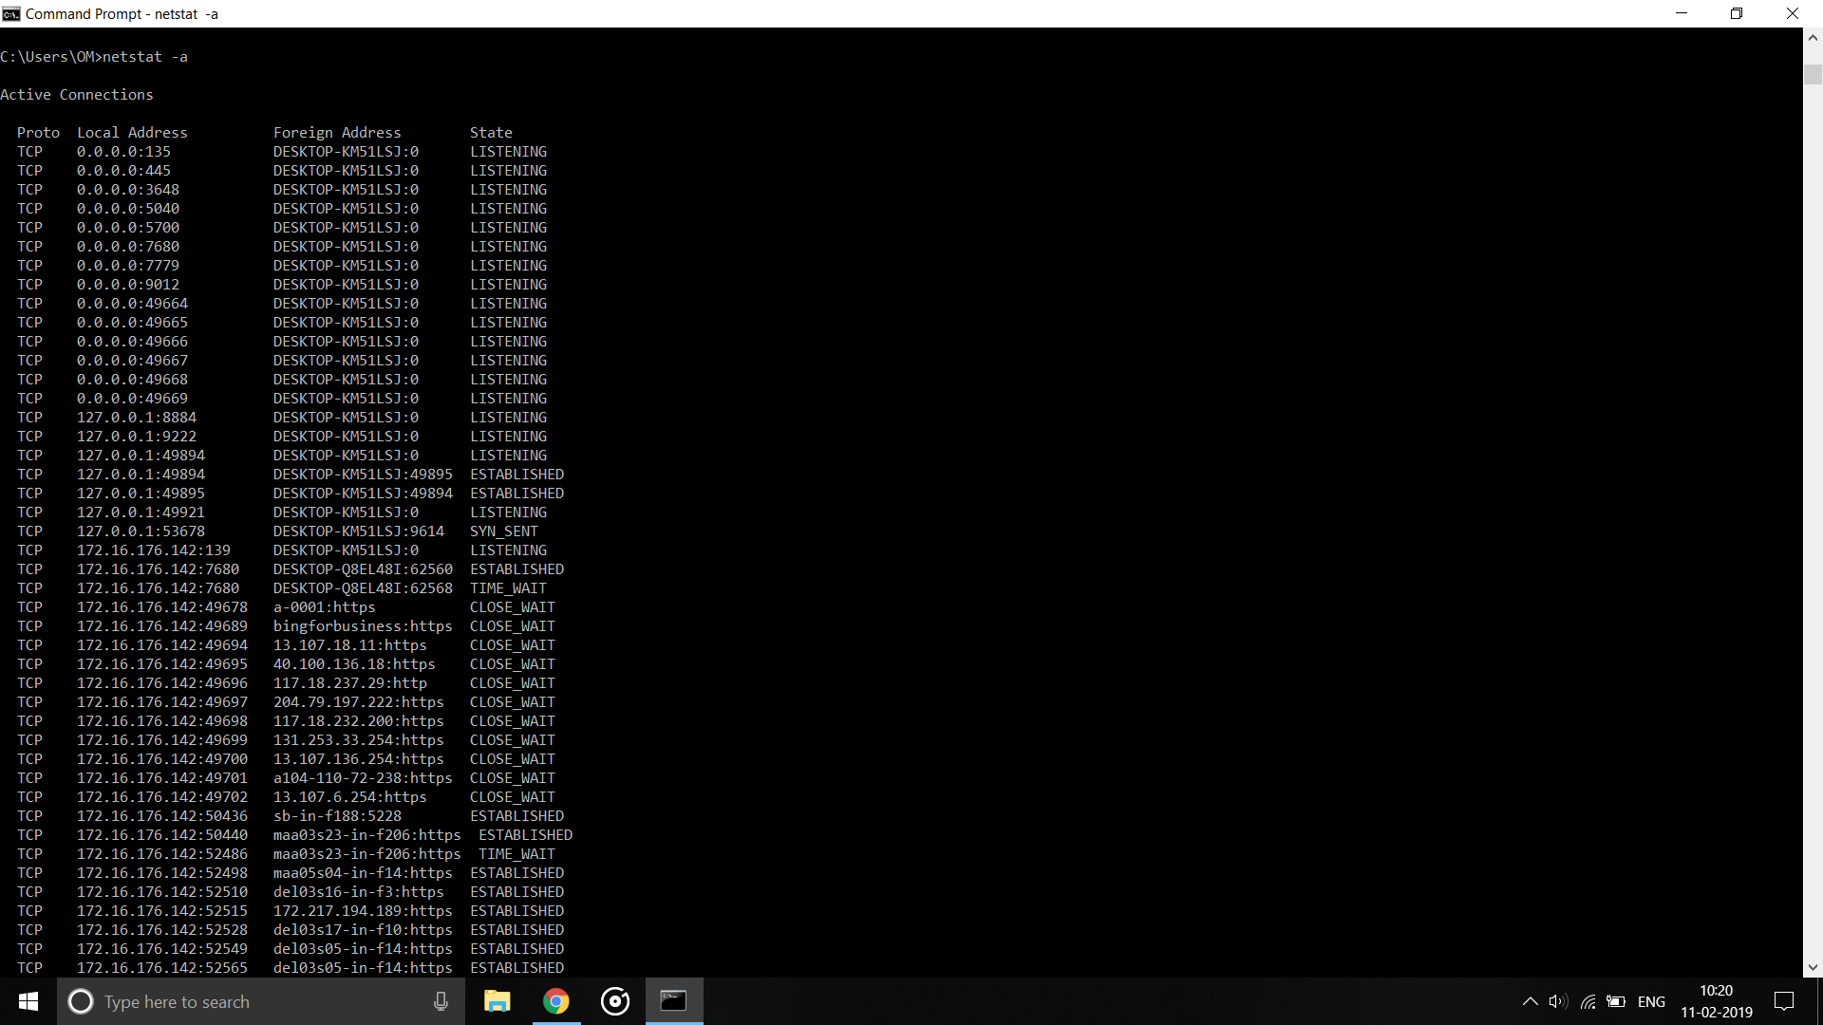

-n

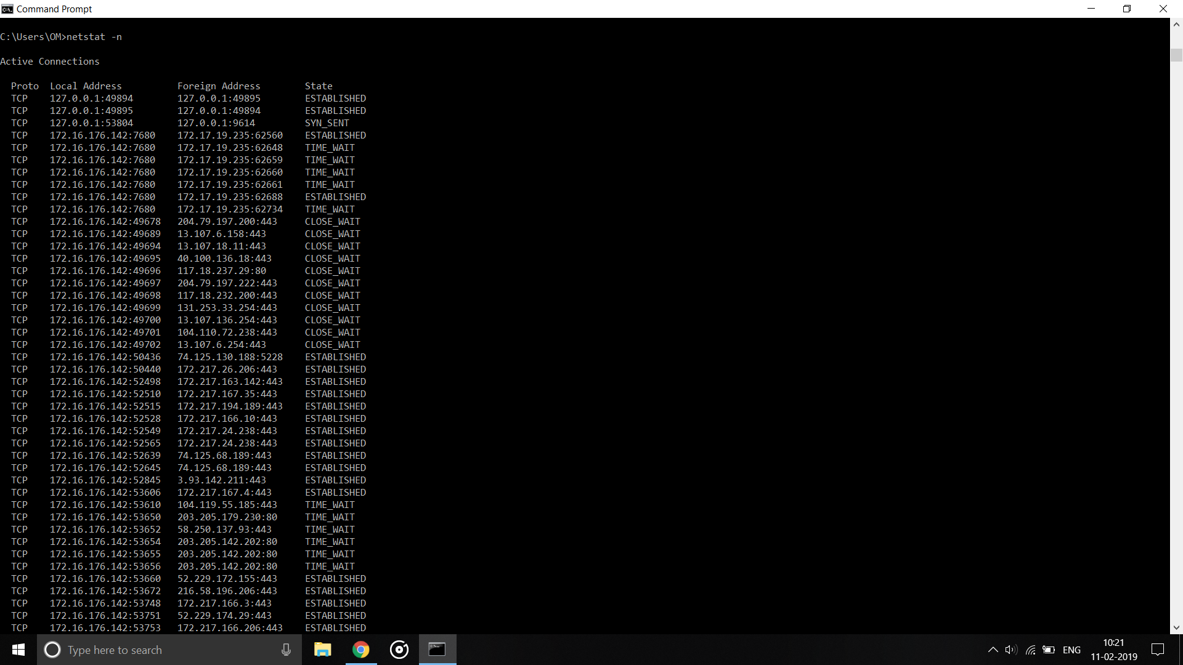

-e = ethernet statistics

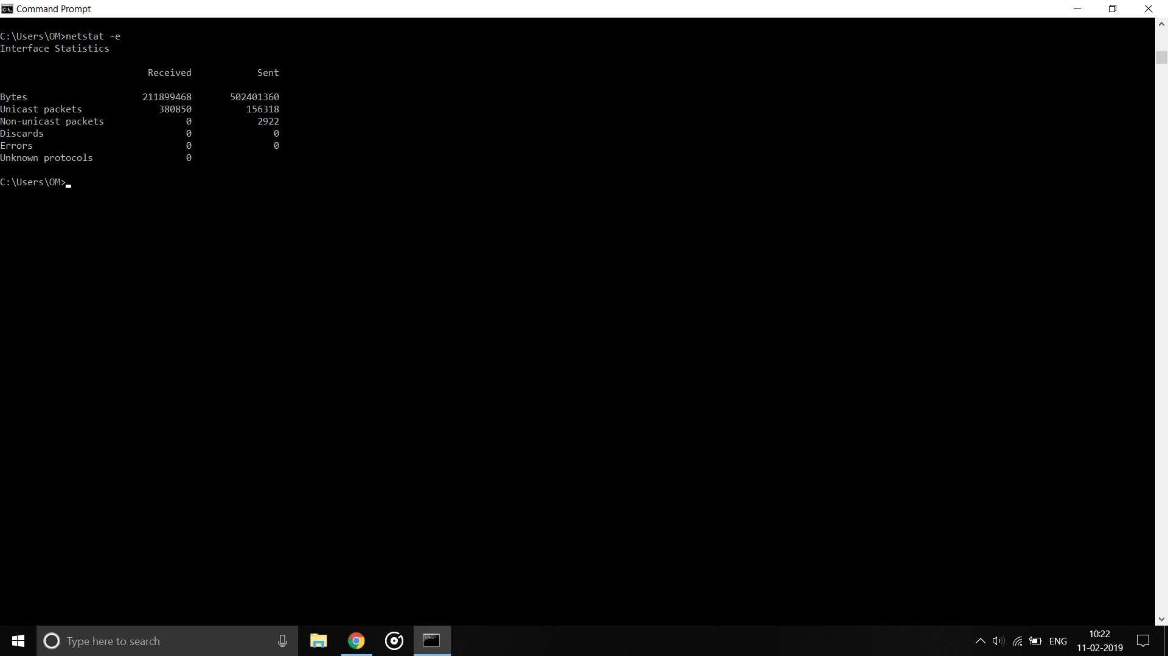

-f

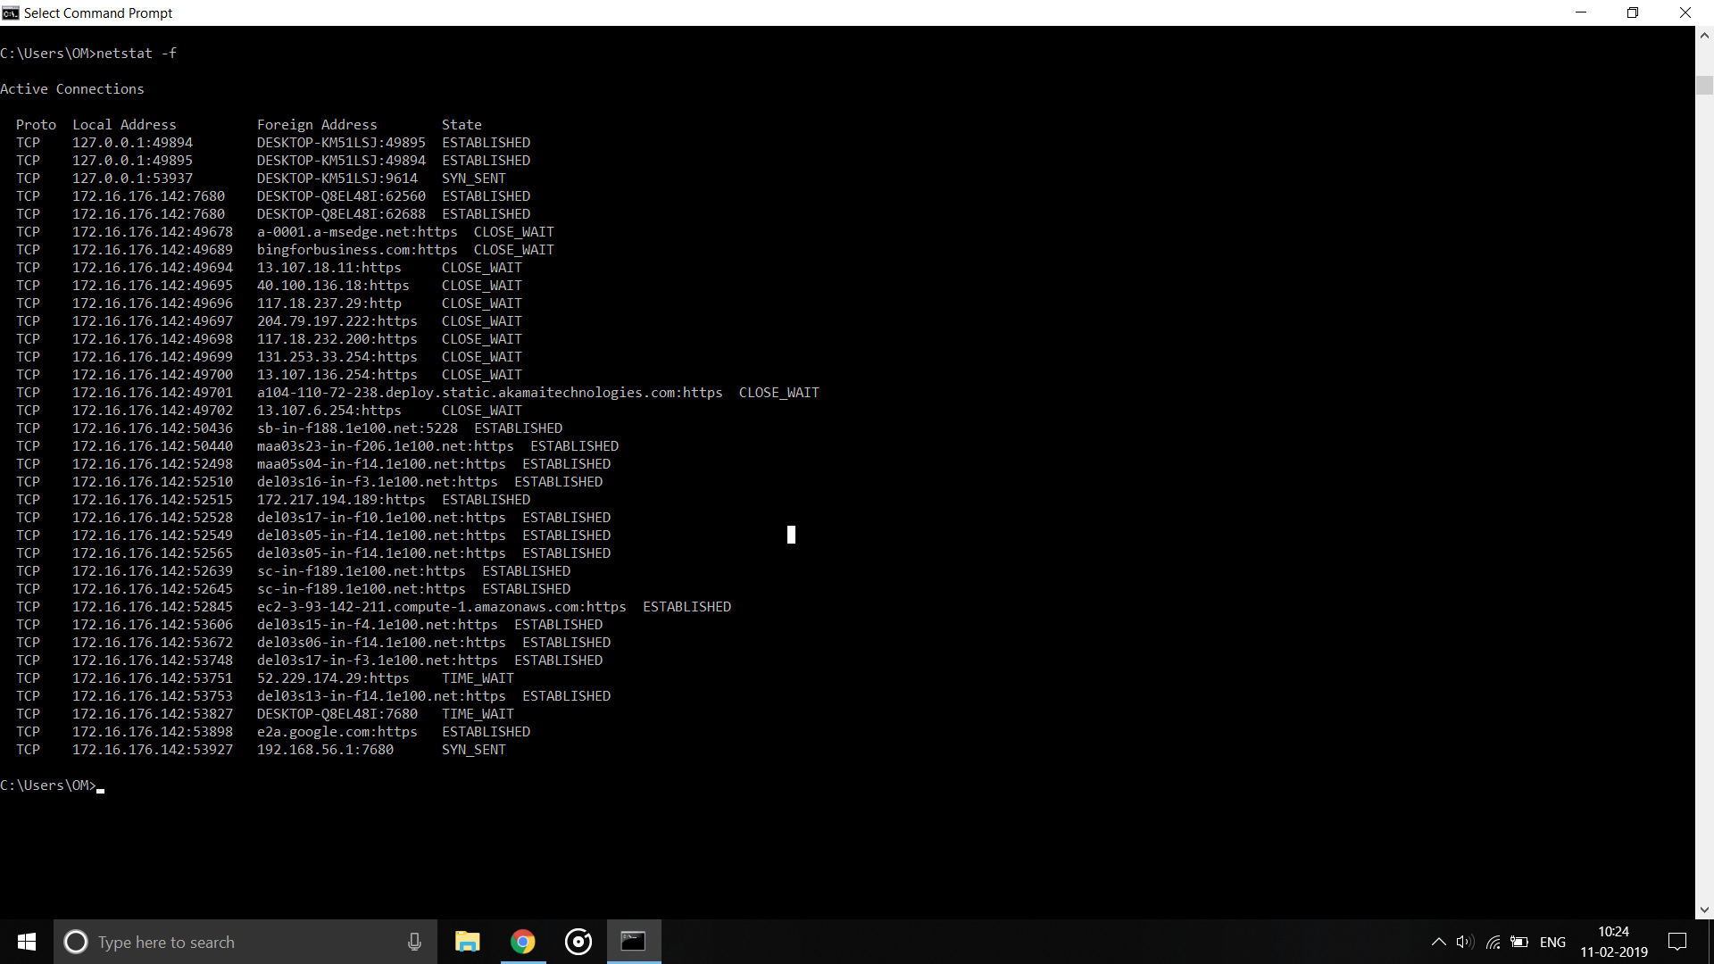

-o

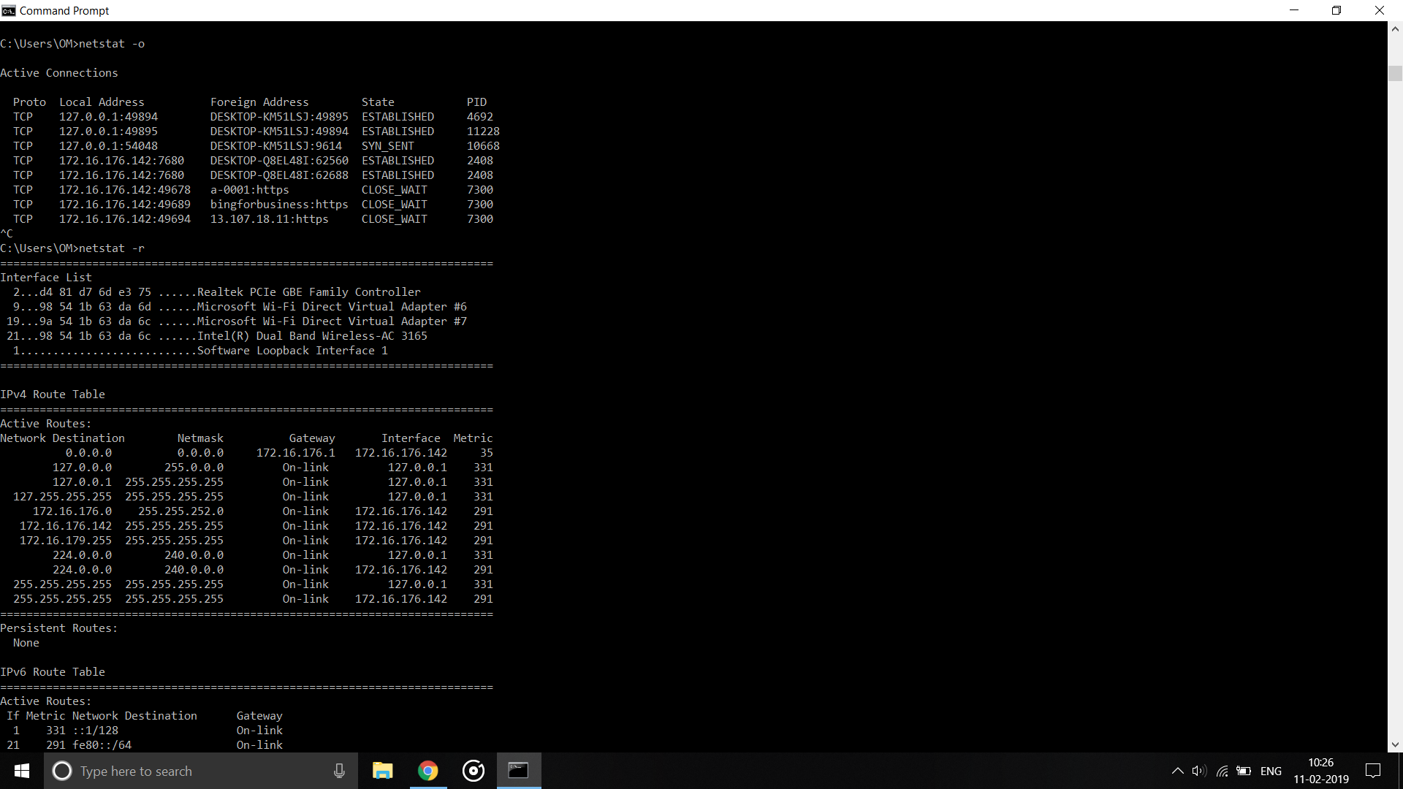

-r

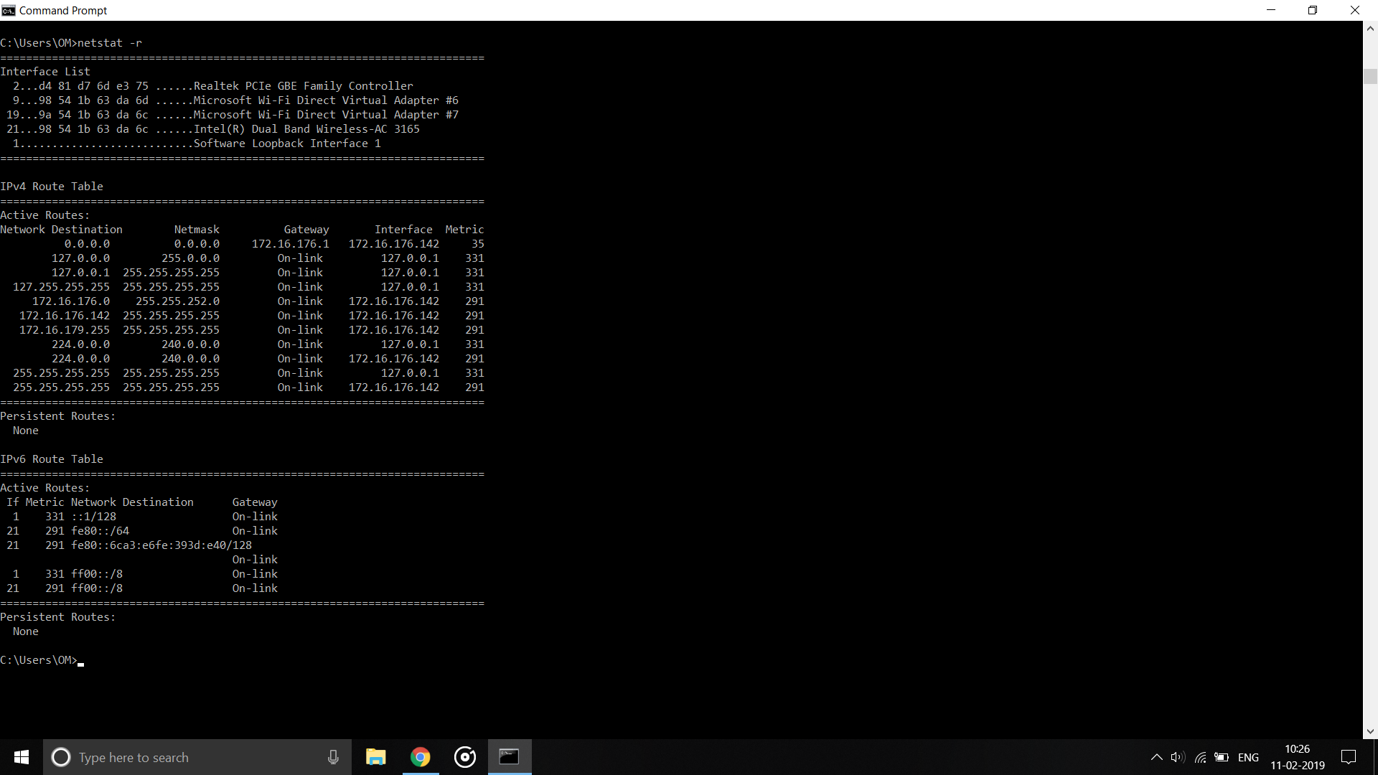

Ping again

ping -r <count> <address>

Ping -s <count><address>

This command is used to set the timestamp count for fixed number of hops.

-w

-S

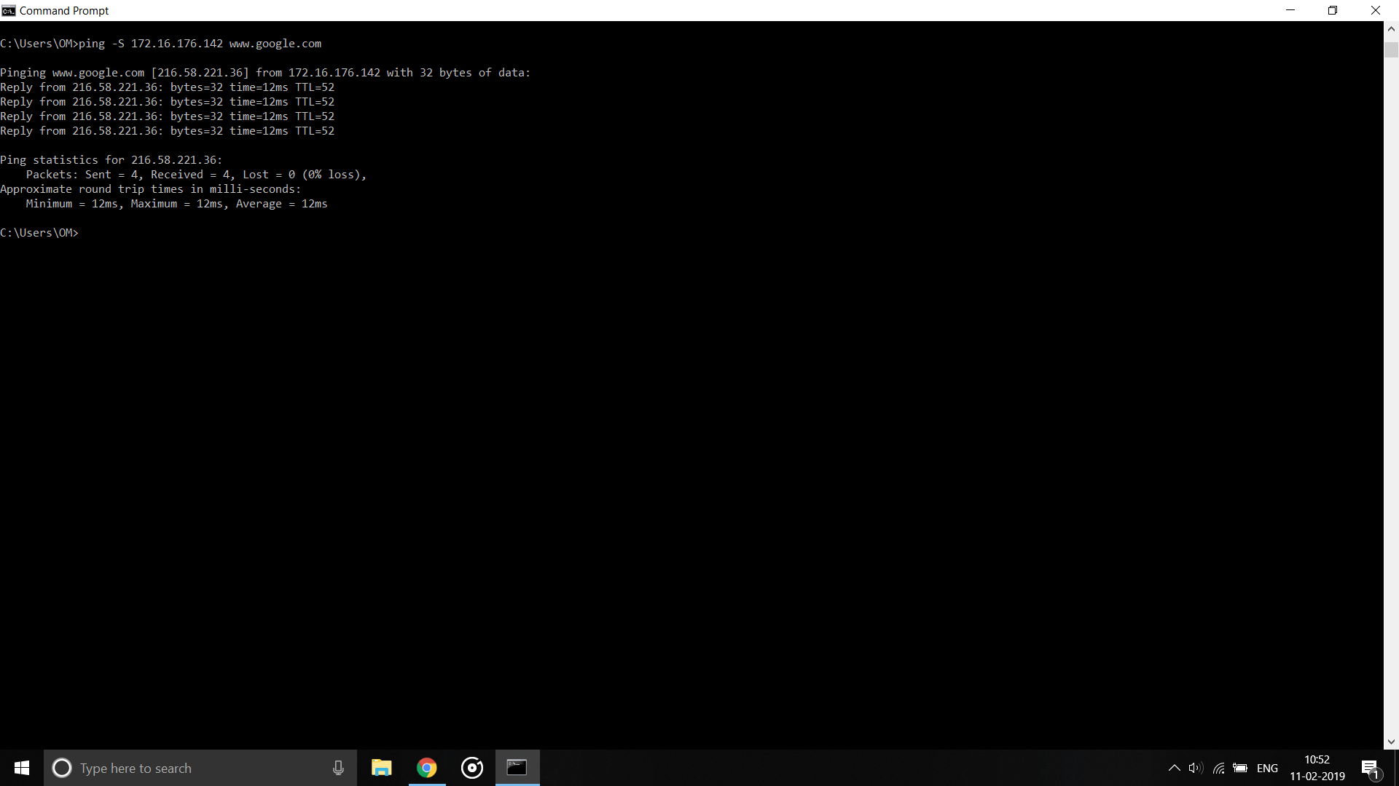

-4

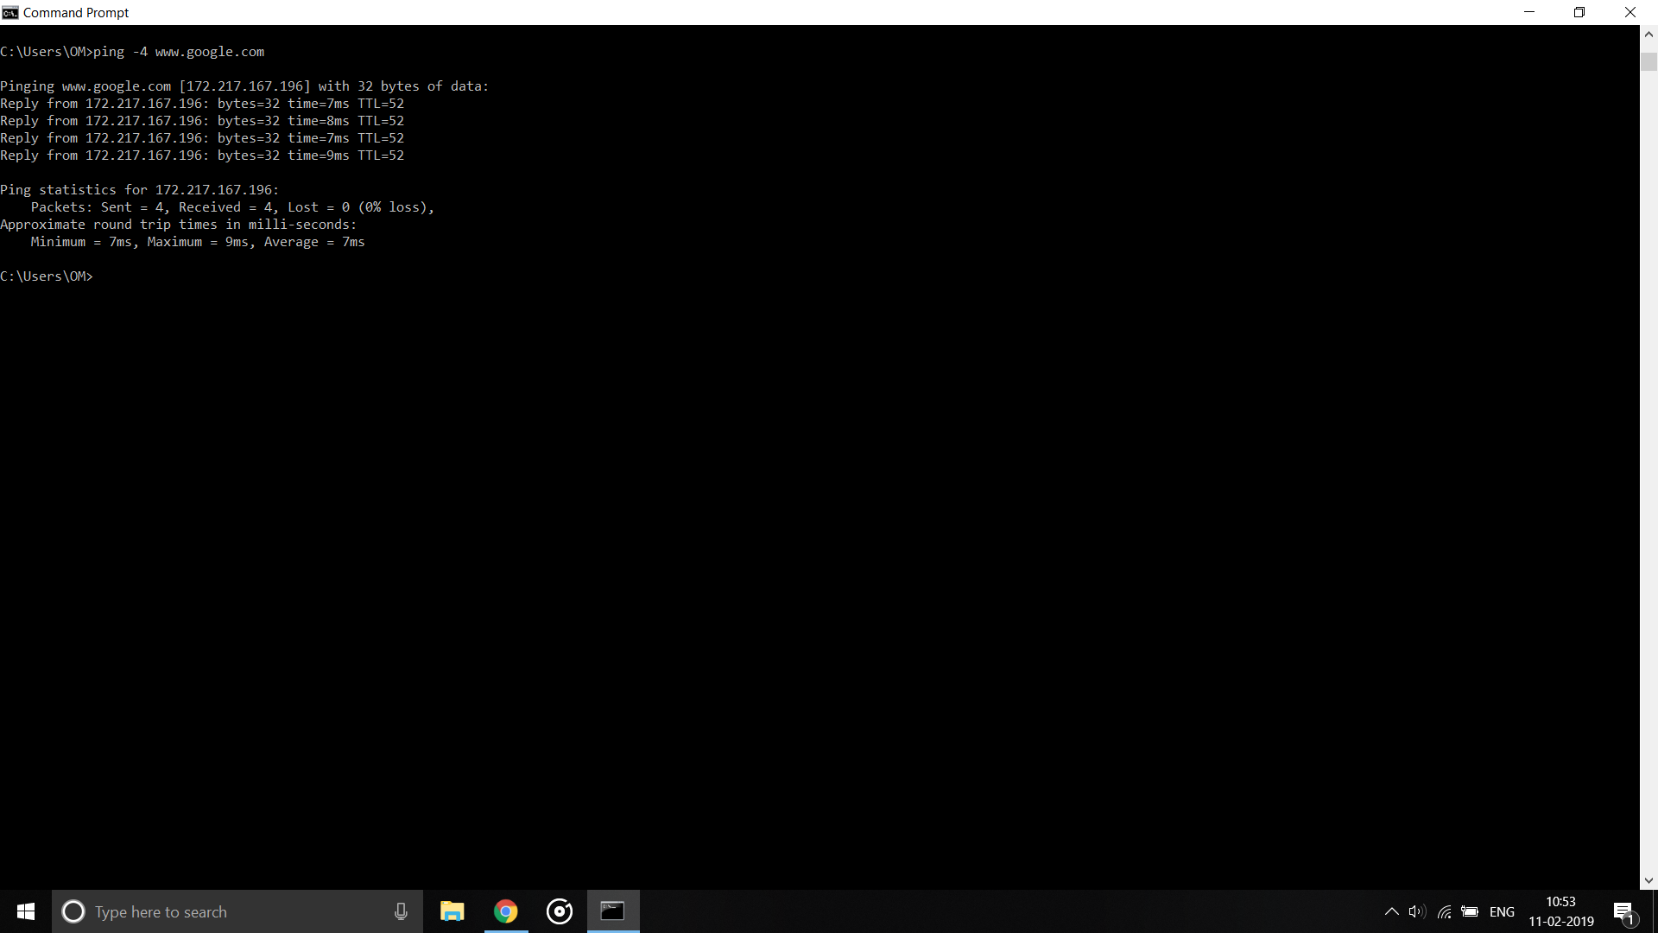

**Practical 5**

**Aim : Network Topologies**

**Types of Network Topology**

Network Topology is the schematic description of a network arrangement, connecting various nodes(sender and receiver) through lines of connection.

## **BUS Topology**

Bus topology is a network type in which every computer and network device is connected to single cable. When it has exactly two endpoints, then it is called **Linear Bus topology**.

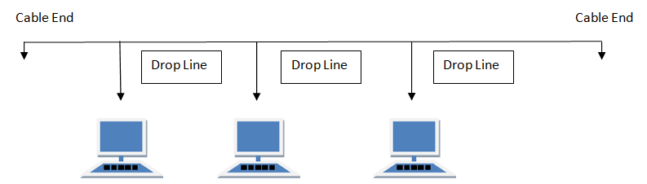

#### **Features of Bus Topology**

1. It transmits data only in one direction.
2. Every device is connected to a single cable

#### **Advantages of Bus Topology**

1. It is cost effective.
2. Cable required is least compared to other network topology.
3. Used in small networks.
4. It is easy to understand.
5. Easy to expand joining two cables together.

#### **Disadvantages of Bus Topology**

1. Cables fails then whole network fails.
2. If network traffic is heavy or nodes are more the performance of the network decreases.
3. Cable has a limited length.
4. It is slower than the ring topology.

## **RING Topology**

It is called ring topology because it forms a ring as each computer is connected to another computer, with the last one connected to the first. Exactly two neighbours for each device.

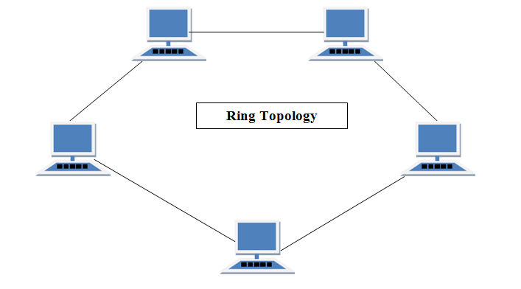

#### **Features of Ring Topology**

1. A number of repeaters are used for Ring topology with large number of nodes, because if someone wants to send some data to the last node in the ring topology with 100 nodes, then the data will have to pass through 99 nodes to reach the 100th node. Hence to prevent data loss repeaters are used in the network.
2. The transmission is unidirectional, but it can be made bidirectional by having 2 connections between each Network Node, it is called **Dual Ring Topology**.
3. In Dual Ring Topology, two ring networks are formed, and data flow is in opposite direction in them. Also, if one ring fails, the second ring can act as a backup, to keep the network up.
4. Data is transferred in a sequential manner that is bit by bit. Data transmitted, has to pass through each node of the network, till the destination node.

#### **Advantages of Ring Topology**

1. Transmitting network is not affected by high traffic or by adding more nodes, as only the nodes having tokens can transmit data.
2. Cheap to install and expand

#### **Disadvantages of Ring Topology**

1. Troubleshooting is difficult in ring topology.
2. Adding or deleting the computers disturbs the network activity.
3. Failure of one computer disturbs the whole network.

## **STAR Topology**

In this type of topology all the computers are connected to a single hub through a cable. This hub is the central node and all others nodes are connected to the central node.

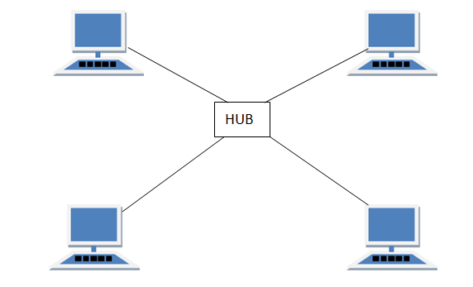

#### **Features of Star Topology**

1. Every node has its own dedicated connection to the hub.
2. Hub acts as a repeater for data flow.
3. Can be used with twisted pair, Optical Fibre or coaxial cable.

#### **Advantages of Star Topology**

1. Fast performance with few nodes and low network traffic.
2. Hub can be upgraded easily.
3. Easy to troubleshoot.
4. Easy to setup and modify.
5. Only that node is affected which has failed, rest of the nodes can work smoothly.

#### **Disadvantages of Star Topology**

1. Cost of installation is high.
2. Expensive to use.
3. If the hub fails then the whole network is stopped because all the nodes depend on the hub.
4. Performance is based on the hub that is it depends on its capacity

## **MESH Topology**

It is a point-to-point connection to other nodes or devices. All the network nodes are connected to each other. Mesh has n(n-1)/2 physical channels to link n devices.

There are two techniques to transmit data over the Mesh topology, they are :

1. Routing
2. Flooding

### **MESH Topology: Routing**

In routing, the nodes have a routing logic, as per the network requirements. Like routing logic to direct the data to reach the destination using the shortest distance. Or, routing logic which has information about the broken links, and it avoids those node etc. We can even have routing logic, to re-configure the failed nodes.

### **MESH Topology: Flooding**

In flooding, the same data is transmitted to all the network nodes, hence no routing logic is required. The network is robust, and the its very unlikely to lose the data. But it leads to unwanted load over the network.

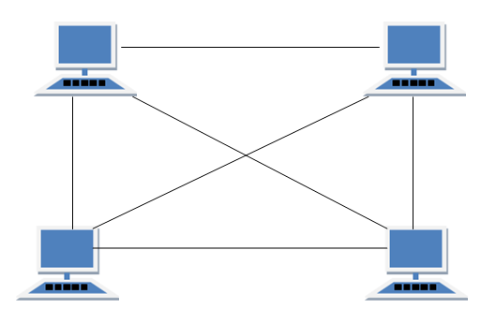

#### 

#### **Types of Mesh Topology**

1. **Partial Mesh Topology :** In this topology some of the systems are connected in the same fashion as mesh topology but some devices are only connected to two or three devices.
2. **Full Mesh Topology :** Each and every nodes or devices are connected to each other.

#### **Features of Mesh Topology**

1. Fully connected.
2. Robust.
3. Not flexible.

#### **Advantages of Mesh Topology**

1. Each connection can carry its own data load.
2. It is robust.
3. Fault is diagnosed easily.
4. Provides security and privacy.

#### **Disadvantages of Mesh Topology**

1. Installation and configuration is difficult.
2. Cabling cost is more.
3. Bulk wiring is required.

## **TREE Topology**

It has a root node and all other nodes are connected to it forming a hierarchy. It is also called hierarchical topology. It should at least have three levels to the hierarchy.

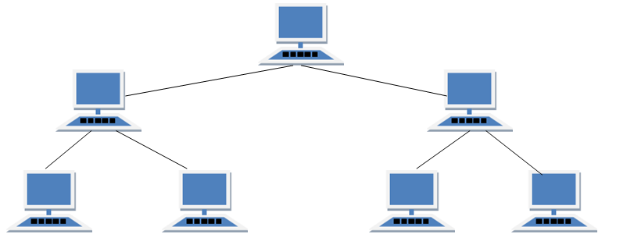

#### **Features of Tree Topology**

1. Ideal if workstations are located in groups.
2. Used in Wide Area Network.

#### **Advantages of Tree Topology**

1. Extension of bus and star topologies.
2. Expansion of nodes is possible and easy.
3. Easily managed and maintained.
4. Error detection is easily done.

#### **Disadvantages of Tree Topology**

1. Heavily cabled.
2. Costly.
3. If more nodes are added maintenance is difficult.
4. Central hub fails, network fails.

## **HYBRID Topology**

It is two different types of topologies which is a mixture of two or more topologies. For example if in an office in one department ring topology is used and in another star topology is used, connecting these topologies will result in Hybrid Topology (ring topology and star topology).

#### **Features of Hybrid Topology**

1. It is a combination of two or topologies
2. Inherits the advantages and disadvantages of the topologies included

#### **Advantages of Hybrid Topology**

1. Reliable as Error detecting and troubleshooting is easy.
2. Effective.
3. Scalable as size can be increased easily.
4. Flexible.

#### **Disadvantages of Hybrid Topology**

1. Complex in design.
2. Costly.

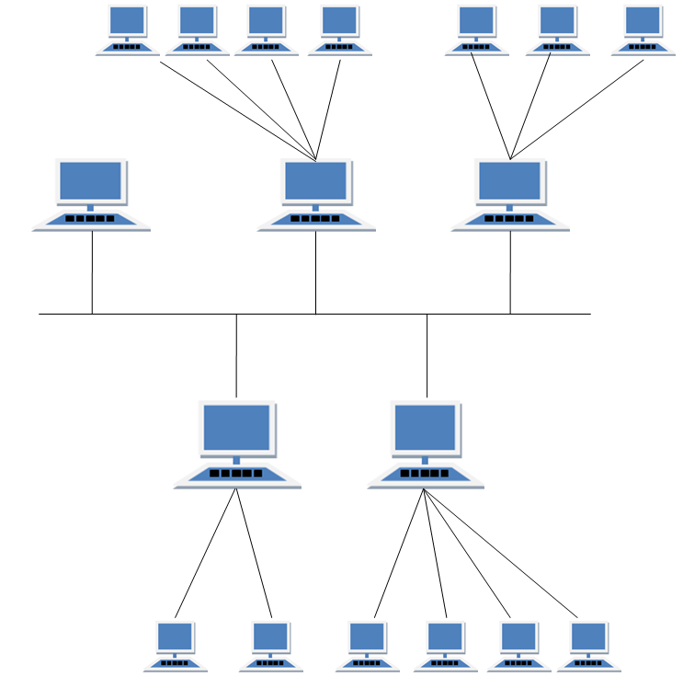

**Practical 6**

**Aim : Network Sharing**

**Practical 7**

**Aim : Hamming Distance Code**

**Code :**

#!/usr/bin/env python

str1 = str(input("Enter the Correct String :"))

str2 = str(input("Enter the Wrong String :"))

str1 = list(str1)

str2 = list(str2)

count = abs(len(str1) - len(str2))

for i in range(min(len(str1),len(str2))):

if not str1[i] == str2[i]:

count += 1

print("The hamming distance between the strings is :",count)

**Output :**

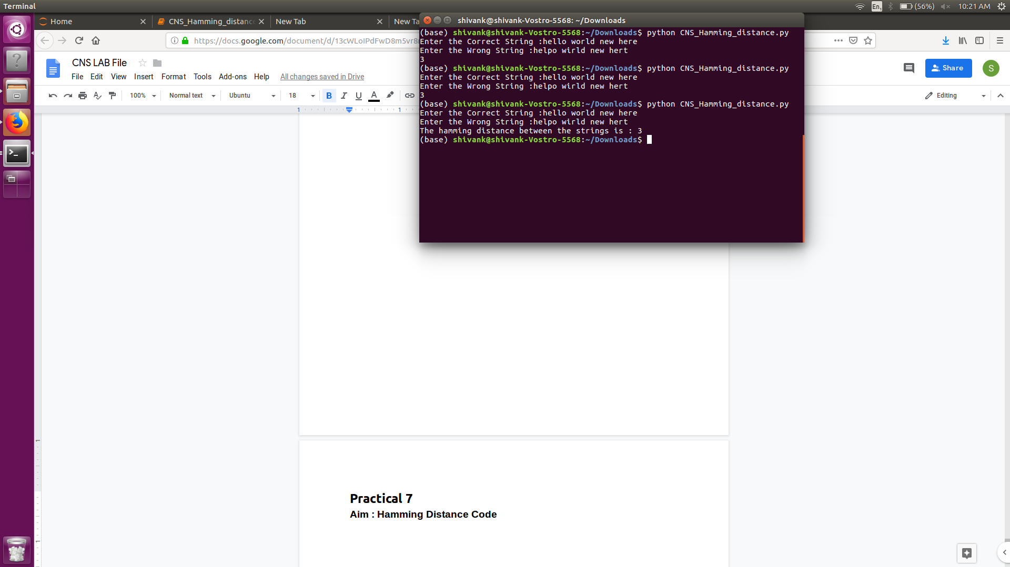

firewall.cx

<https://www.fs.com/network-communication-cables-that-power-your-internet-aid-393.html>